Qlik Sense workshop

Objective:
By the end of this workshop, we will learn to associate data, clean and transform it, and create visualizations like bar charts, KPIs, and maps using Qlik Sense.

Data Association
- Identify Associations: Start by understanding how datasets are related.
- View Associations: Use the Qlik Sense Associative Engine to visualize the relationships between data tables

Data Upload
  - Option 1: Upload from a local computer.
  - Option 2: Connect to an external data source.
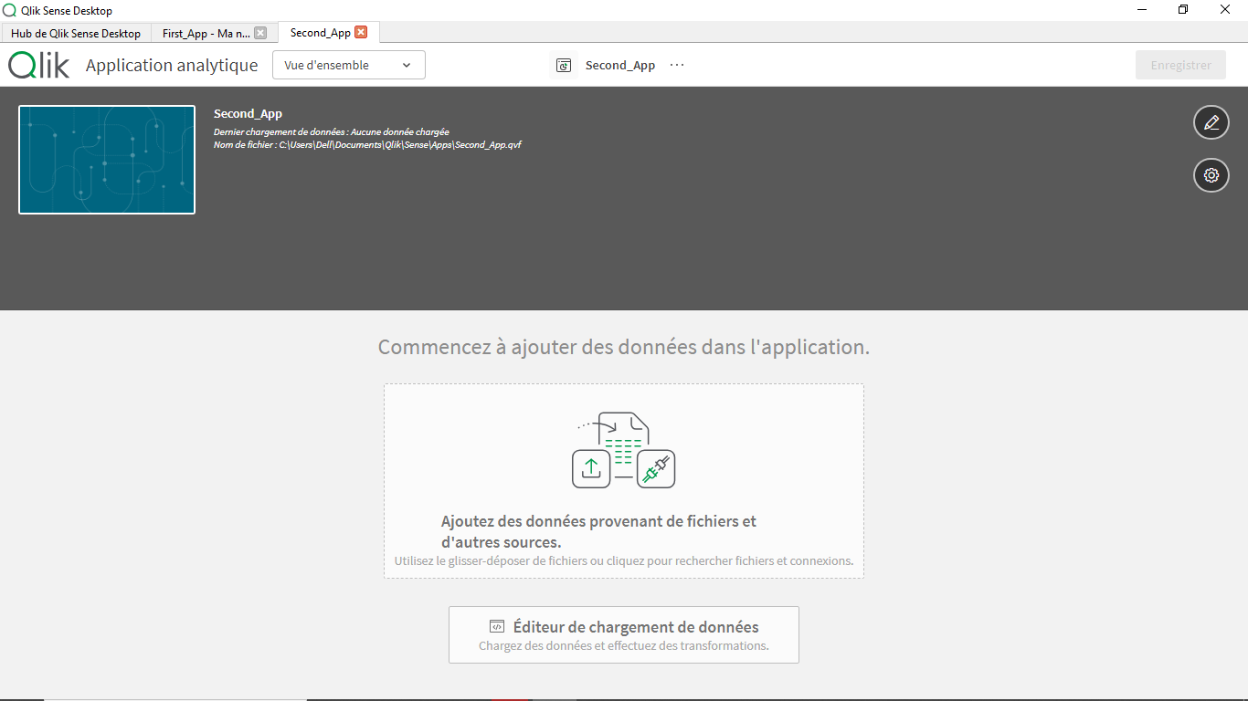
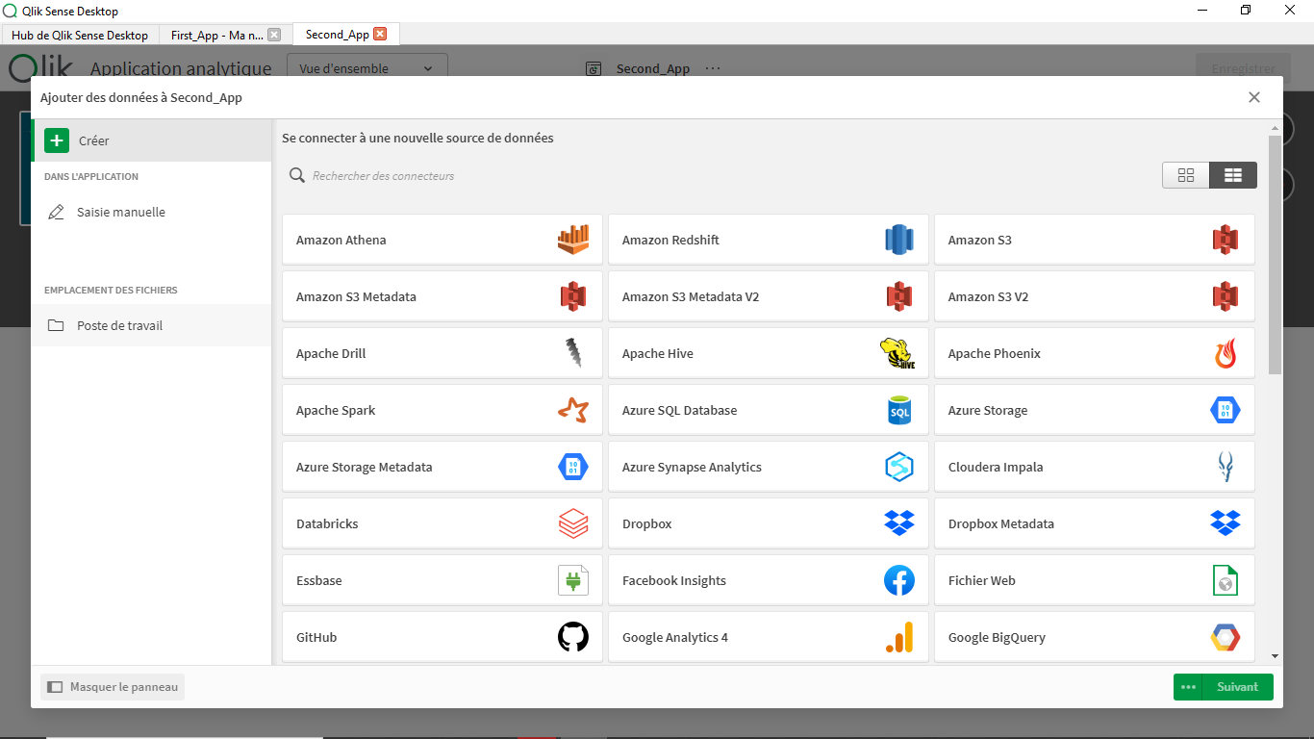

Drag and Drop: Use the drag-and-drop functionality to quickly upload your files.

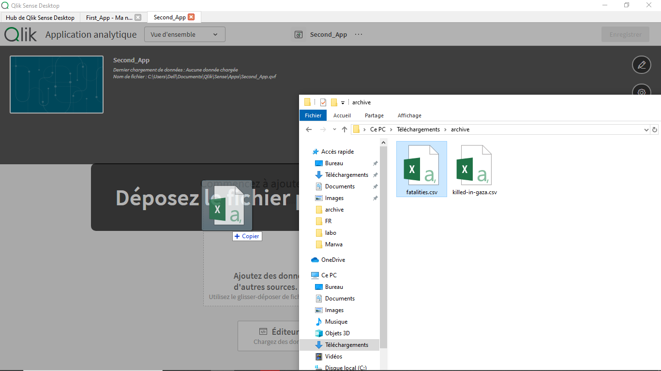

Data Management
- Change Column Names: Rename columns for clarity .
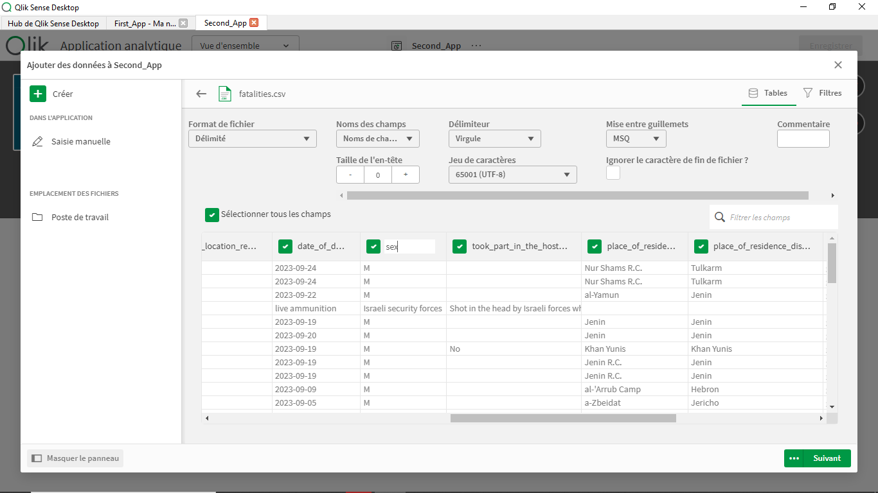
- Use the Data Manager: Review and organize your uploaded datasets in the Data Manager
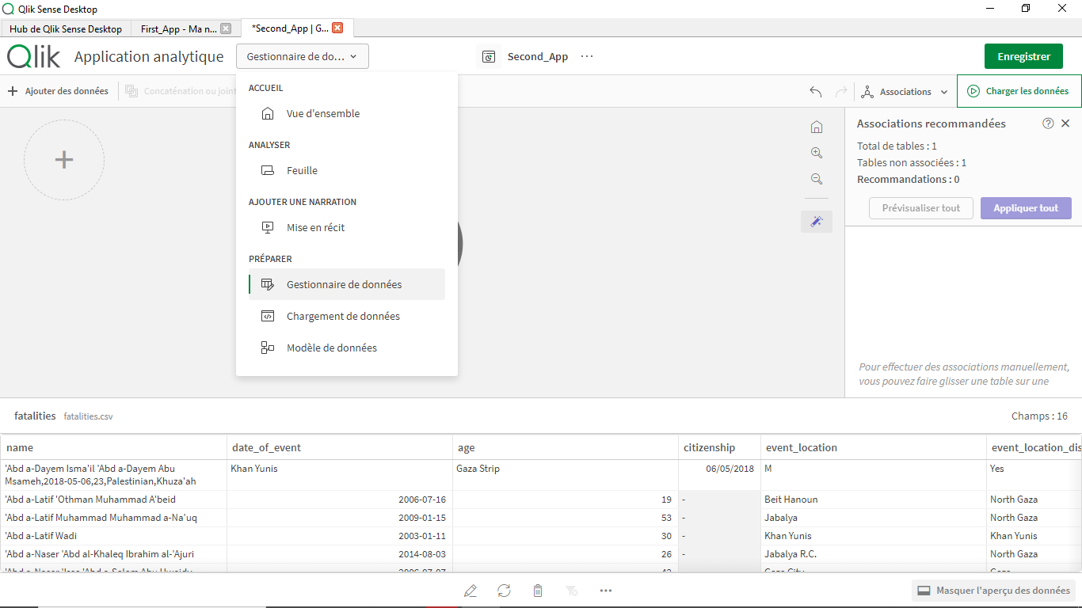

Table Association
- Identify Similarities: Qlik Sense will highlight similarities between tables.
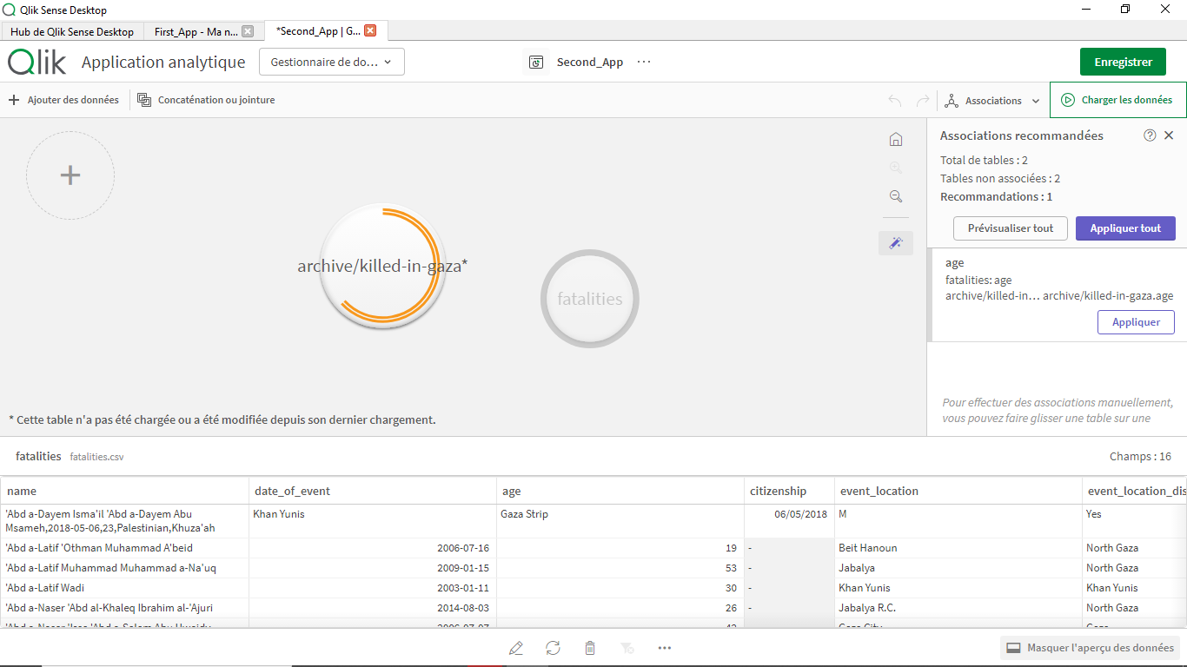
2. Drag to Associate: Link tables by dragging elements.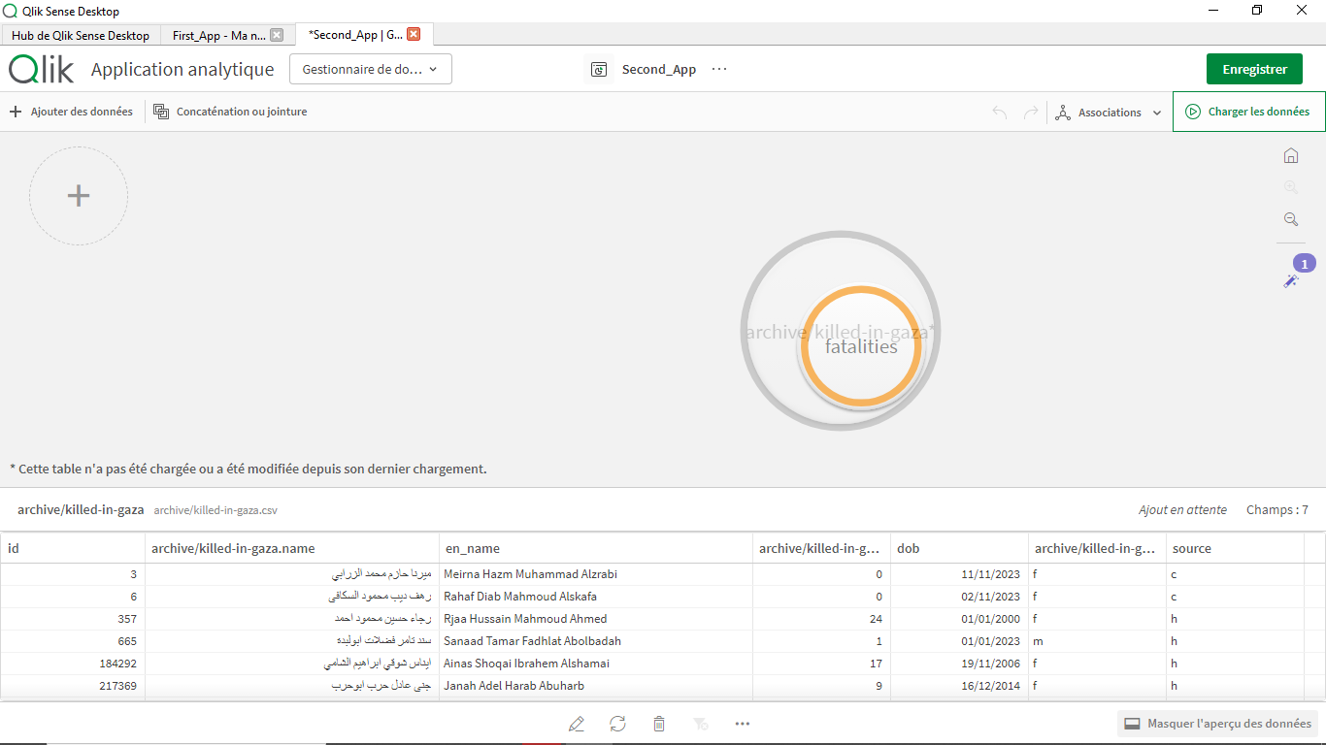
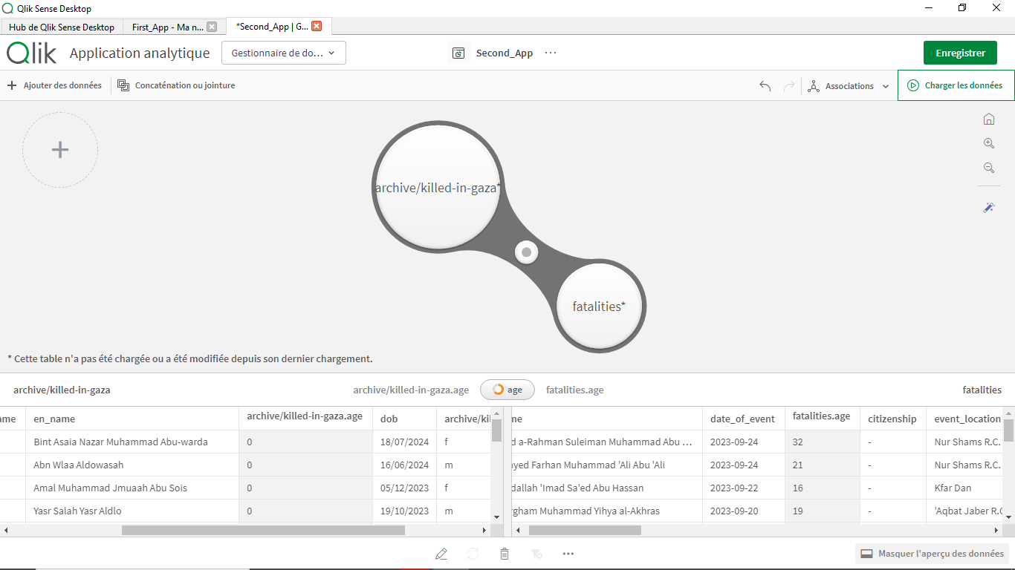
3.Customize Associations: Improve the connection by linking tables using specific fields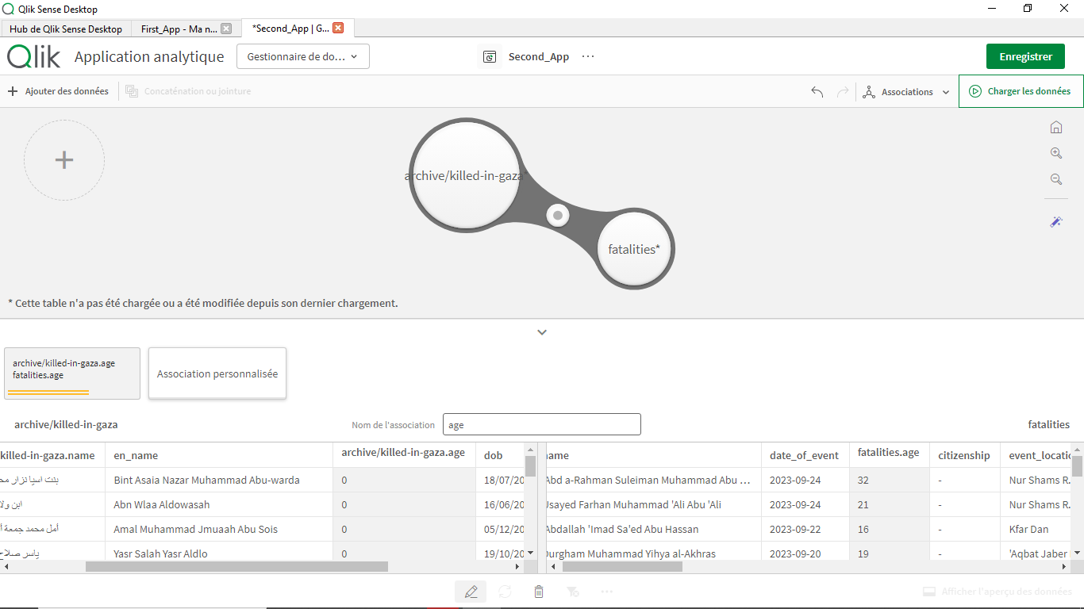
Using the sex Column in this exemple :
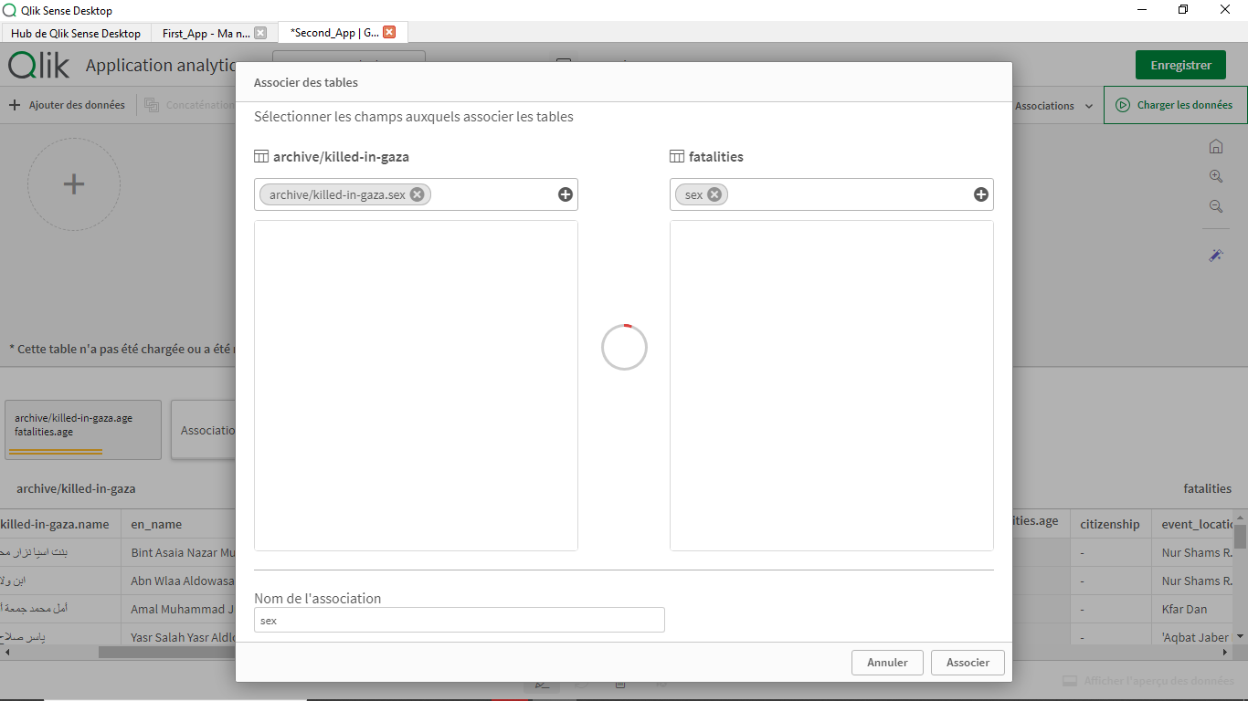
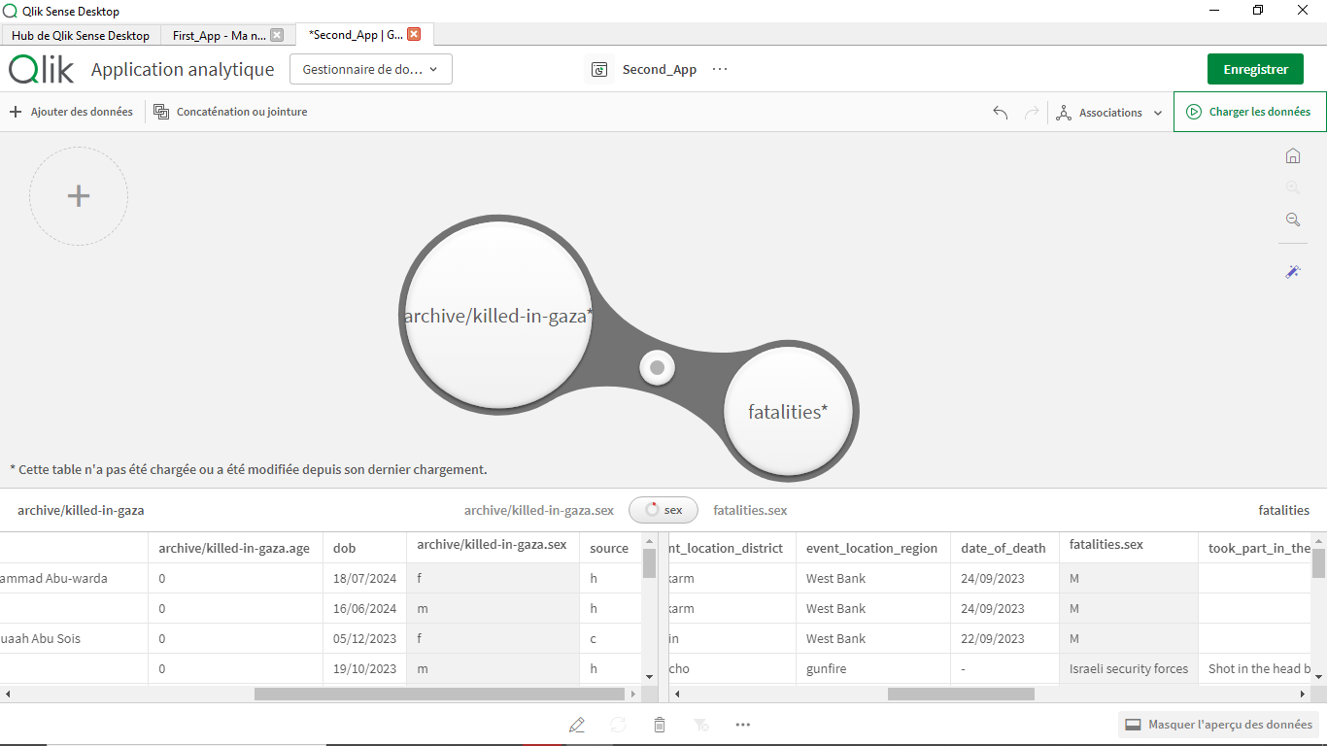

View In Data Model :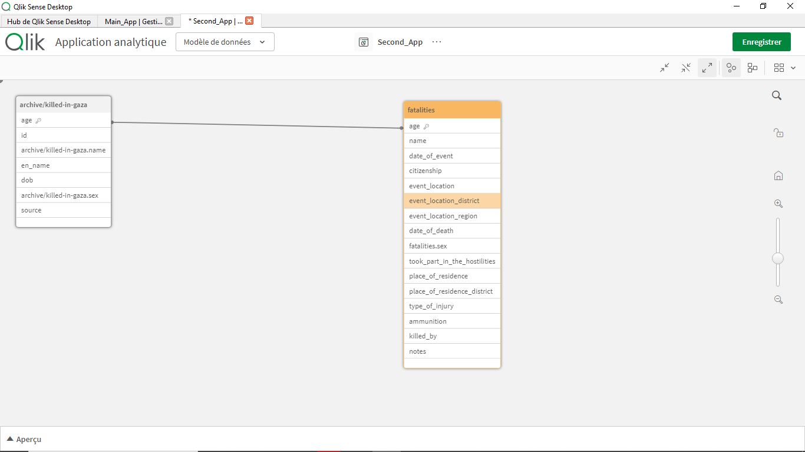

Analyzing Connections
Use the Associative Engine to see how fields and data points are connected
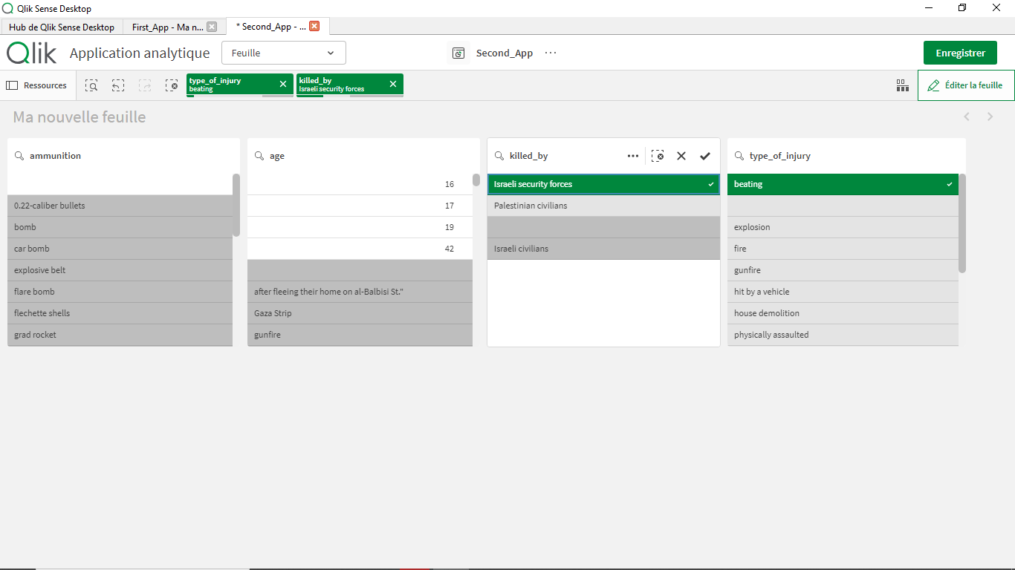
When you load multiple tables, the Associative Engine analyzes the fields and their values to identify connections
When you select a field or filter data, the engine dynamically shows related and unrelated data across the entire model.

Creating Dashboard :
Loading Dataset
Step 1: Set Up Connections
- Establish links between your data sources and Qlik Sense.
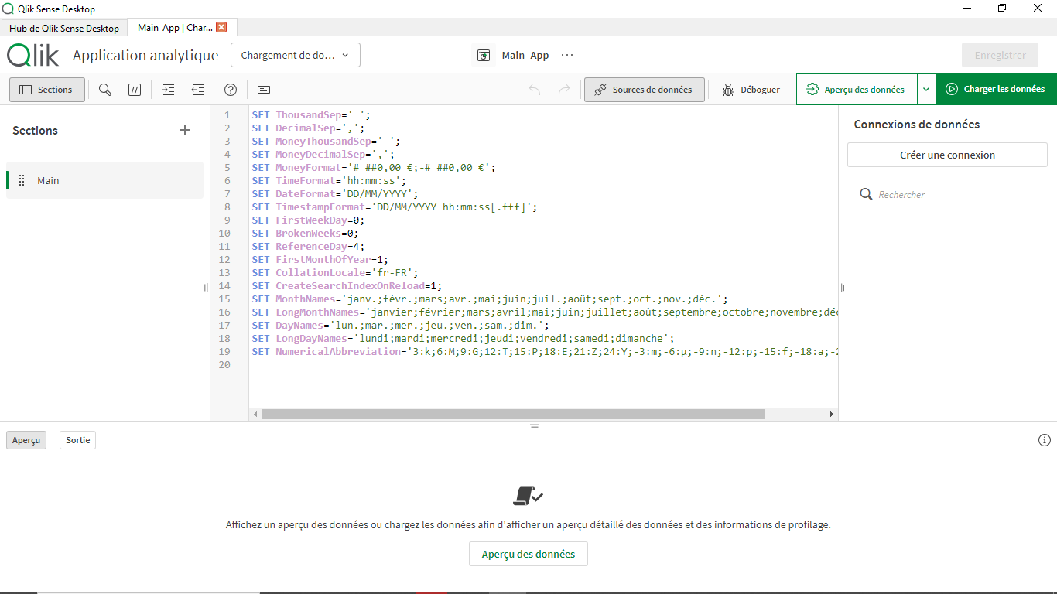
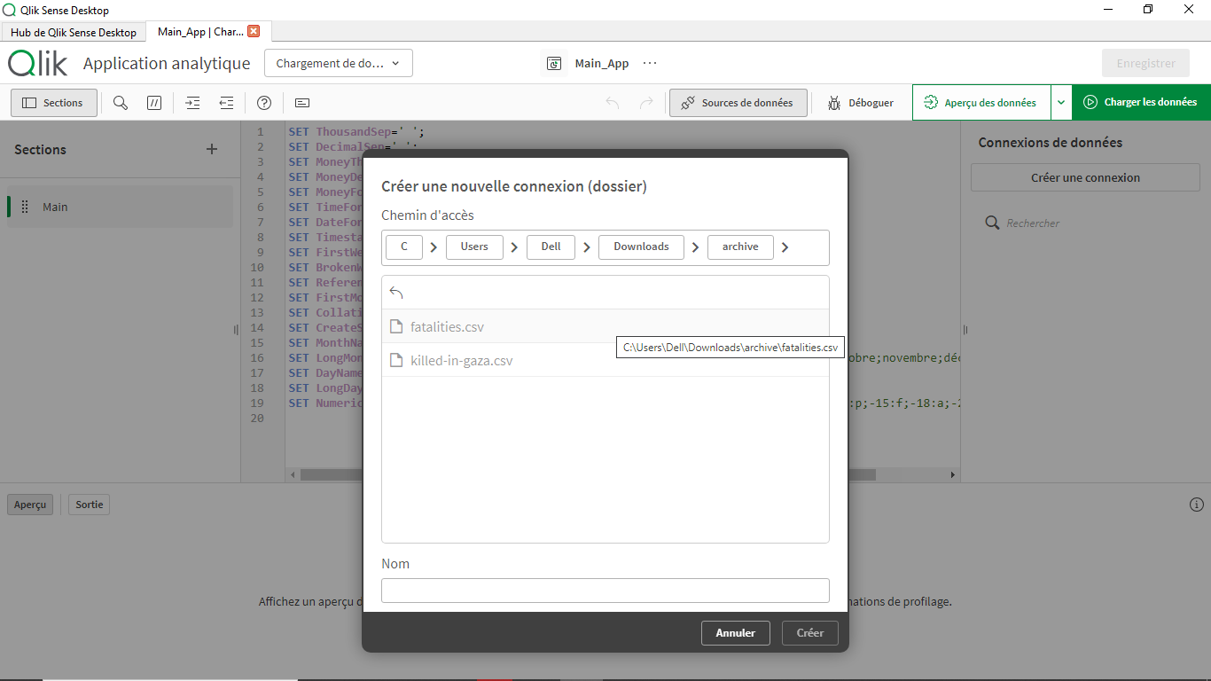
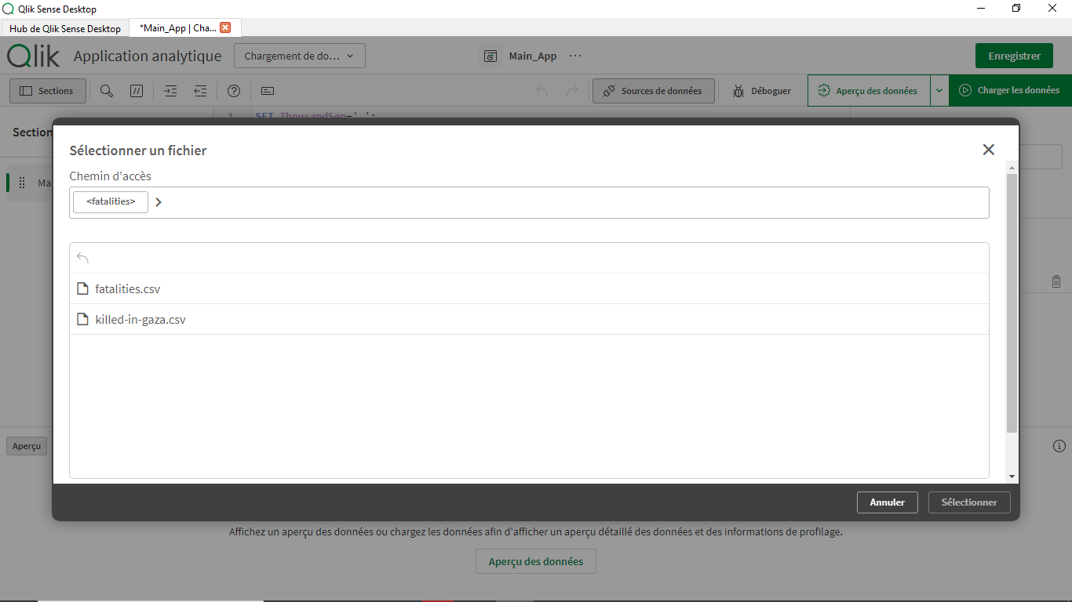
Step 2: Choose Dataset
- Upload desired Dataset and filter columns

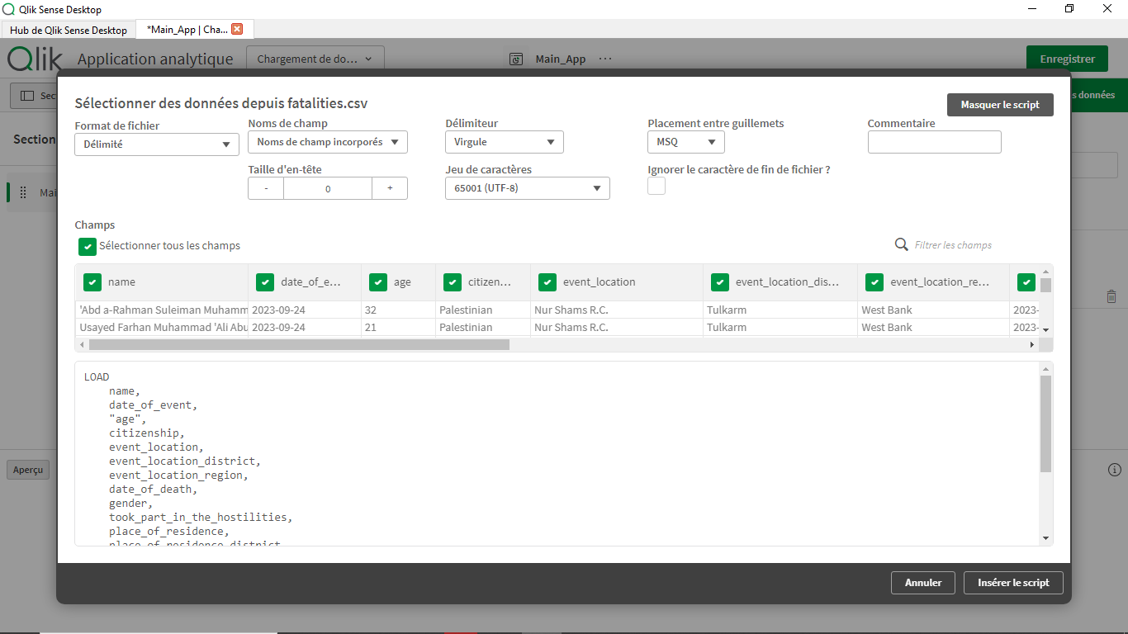
Step :Execute Script
- Run the script to view changes in Data Manager

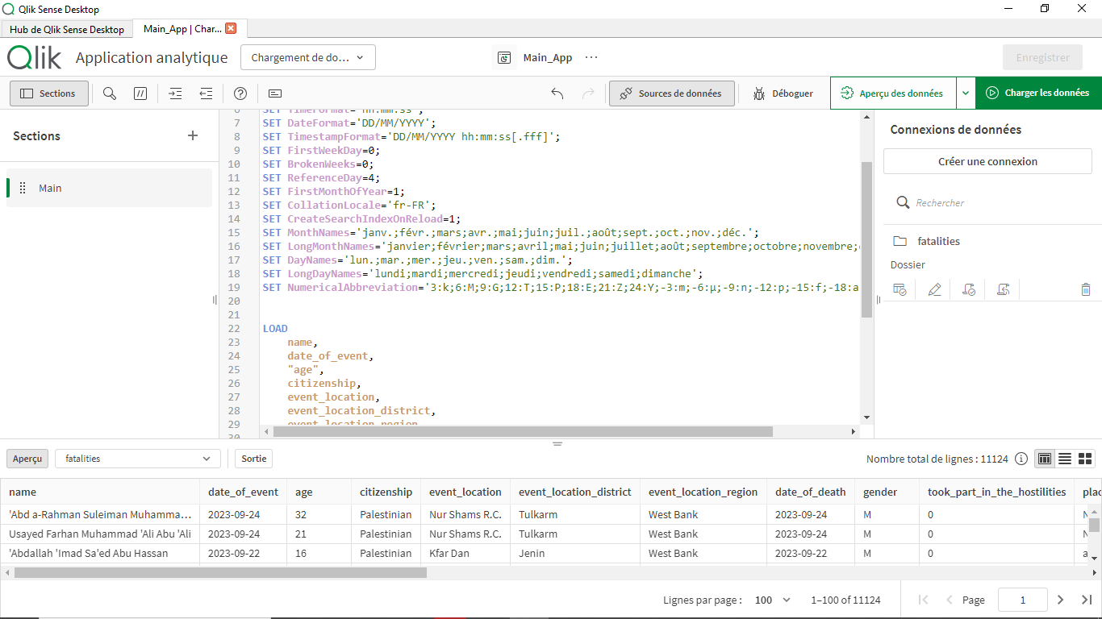
Step 4: Preview Data:
The preview step helps you validate that the data was imported correctly and ensures that you can start analysis without errors.
• Check Data Fields: Use the preview function to view a snapshot of your data. Verify that all columns and rows are loaded as expected.
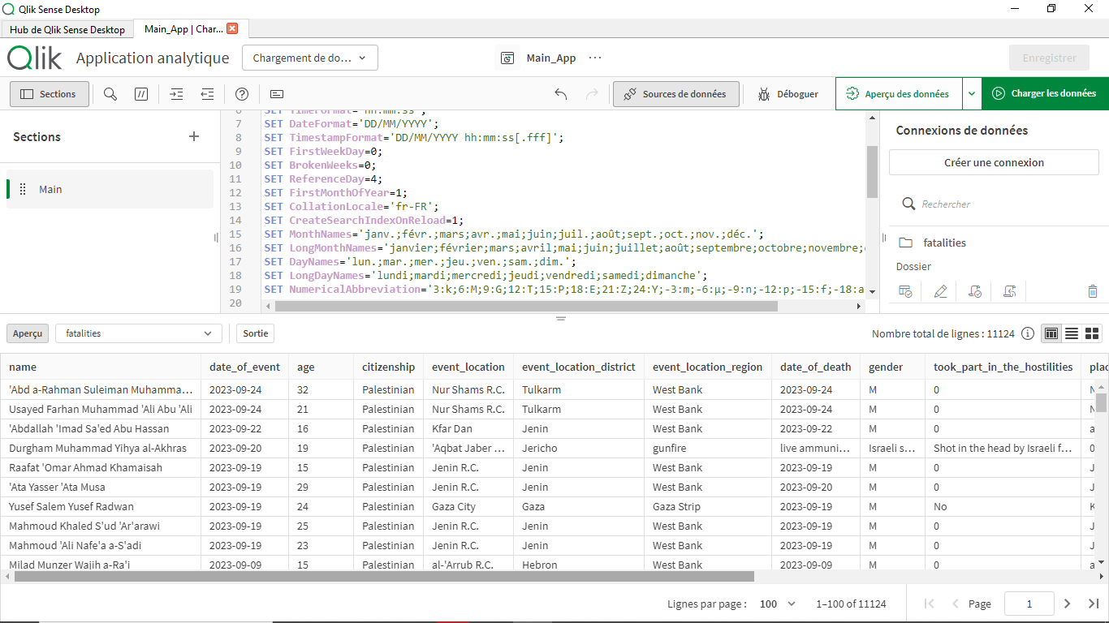
• Validate Data Types: Confirm that fields like Date or Region are correctly interpreted by Qlik Sense.

QlikSense recognized date_of_death as a Date Type :
  - We’ll extract month and year into a new Column
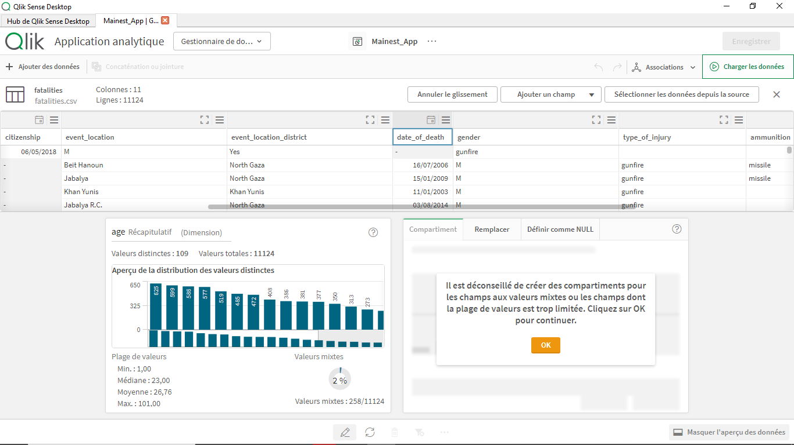

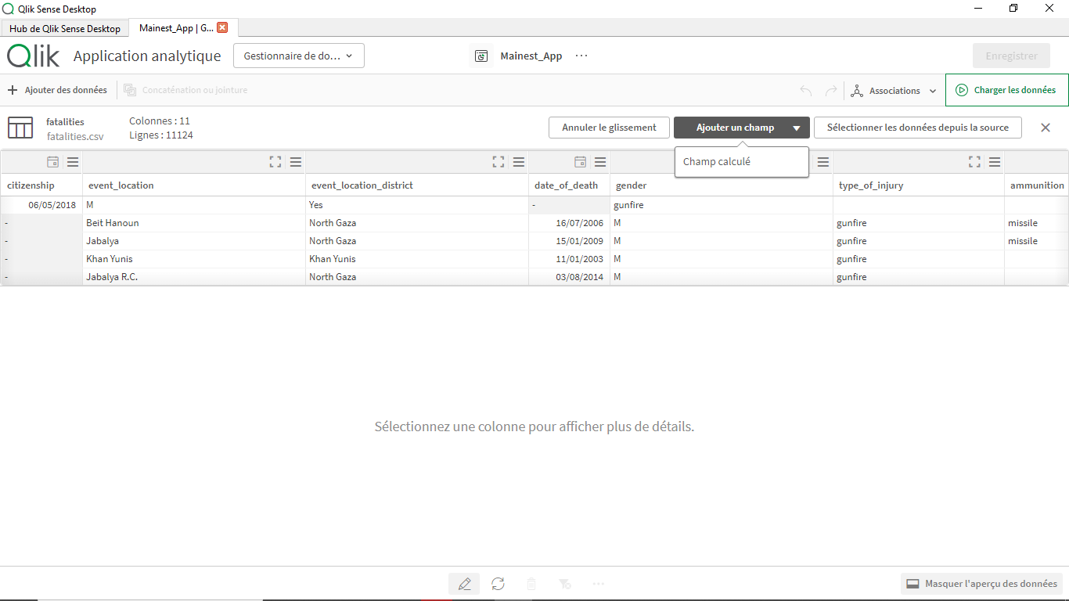
Expression :
Month(date_of_death)
&
‘-‘
&
Year(date_of_death)

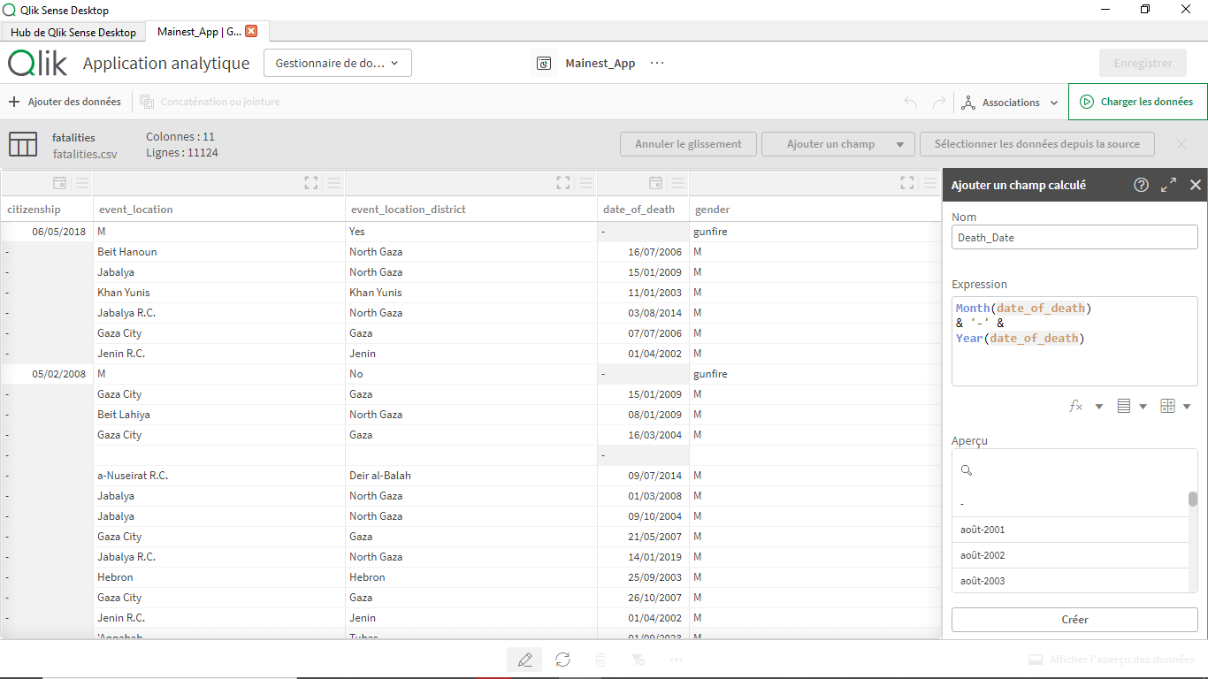
Our First BarChart :

Step 1: Choose the Bar Chart Option
- Go to the Visualization Pane in your Qlik Sense dashboard.
- Drag and drop the Bar Chart visualization onto the canvas.

Step 2: Add Data Fields
- Dimension (x-axis):
  - Choose the field that represents categories or groups,in our case :
    - Count(name) .
- Measure (y-axis):
  - For the timeline :
    - Death_Date .

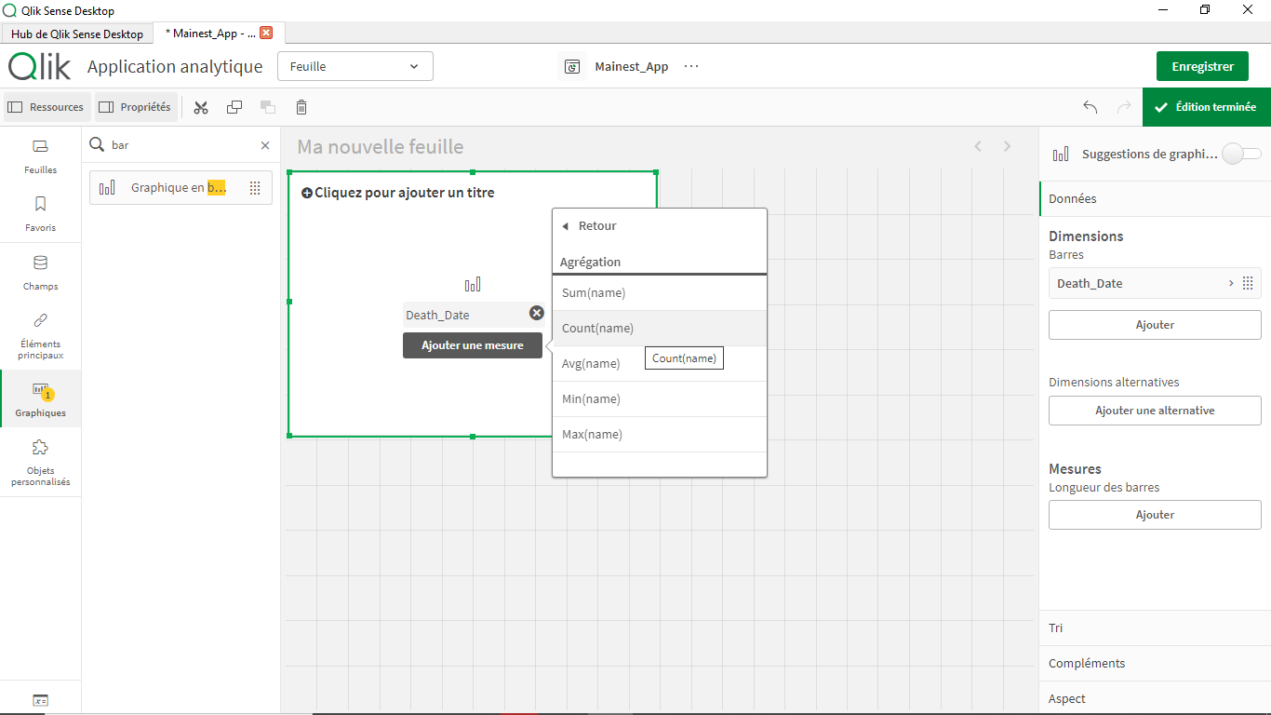
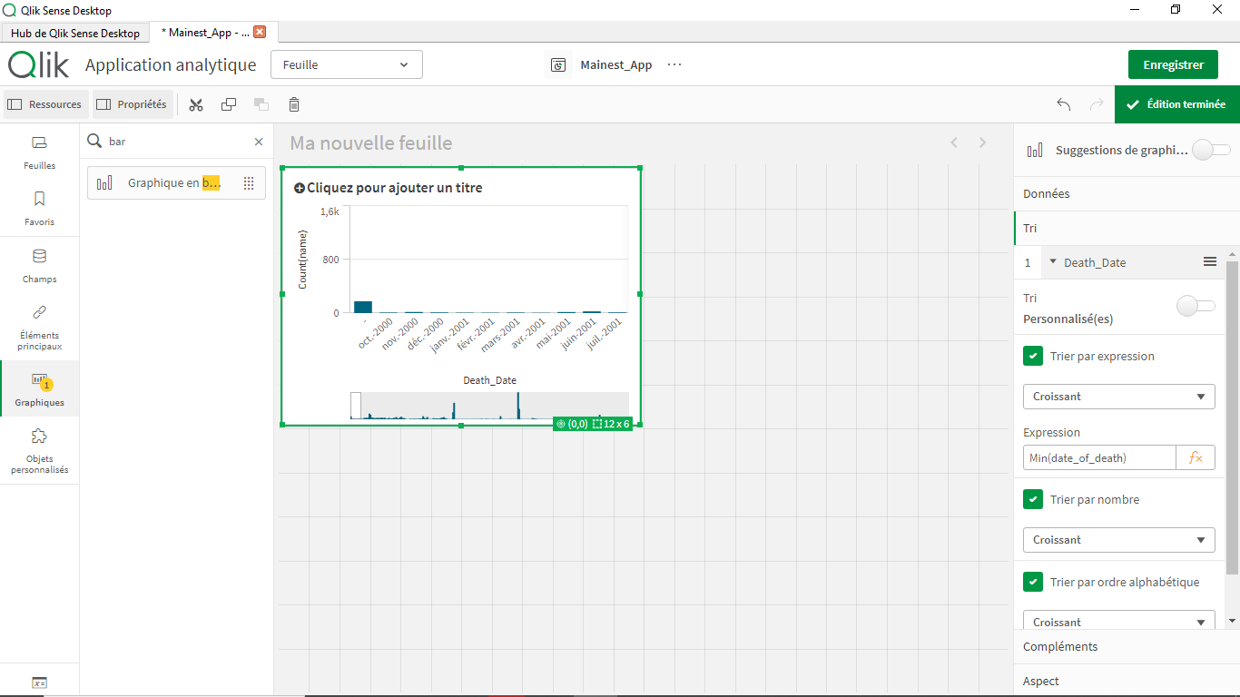
To sort by months and not Alphabetically we’ll use Min Function
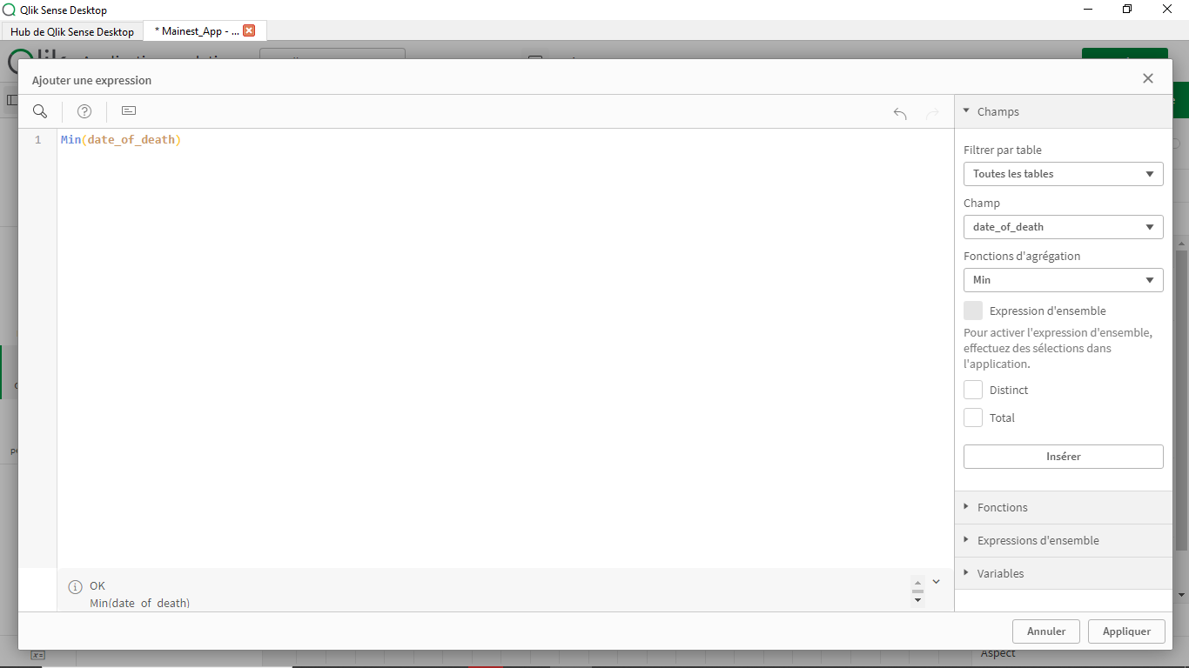

Adding a KPI Indicator :

Step 1: Open the Visualization Pane
- In your Qlik Sense workspace, go to the Visualization Pane.
- Drag and drop the KPI Object onto your canvas.
Step 2: Select a Measure :
For the Measure we’ll use Count(name) as i twill count the number of individuals deceased .

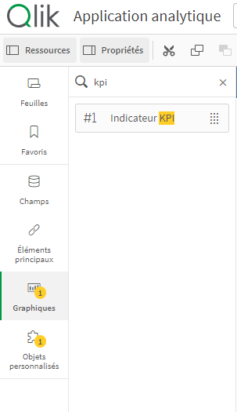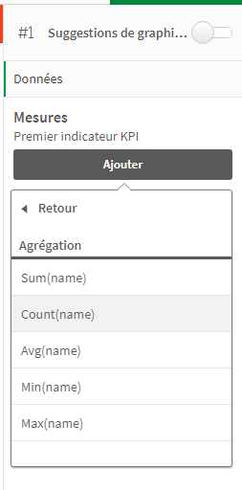
  - Adding a Map to visualize Deaths by district :
A map visualization is a powerful way to represent geographical data, and enables you to see spatial patterns and trends. Here’s how to create and customize a map in Qlik Sense to visualize deaths by region:

Step 1: Open the Visualization Pane
- In your Qlik Sense dashboard, go to the Visualization Pane.
- Drag and drop the Map / Carte object onto your canvas.

Step 2: Add Data for Geographic Information
- Location Field (Dimension):
  - For mapping, you’ll need a field that contains geographic data.
  - In our case ‘event_location_district’
- Measure (Value to Visualize):
  - Select the metric you want to display on the map. For example:
    - Total deaths (Count(name))
Choisir le type de carte et couche .
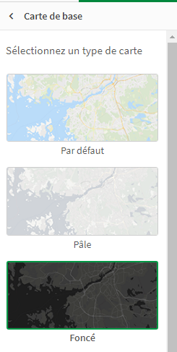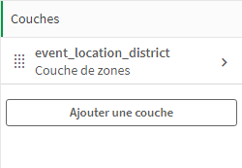
On spécifie ‘PS’ pour le pays pour focaliser la recherche .
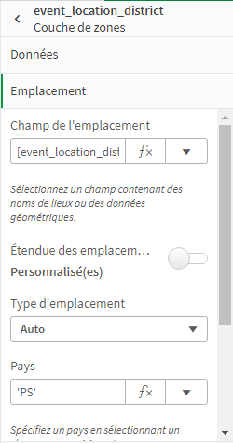

  - Adding a second Map to view Deaths by specific regions :
- Choosing ‘event_location’ for the map layer
- Specifying ‘IL’ as country for ISRAEL
- Count(name) as a measure
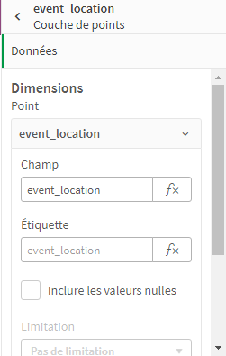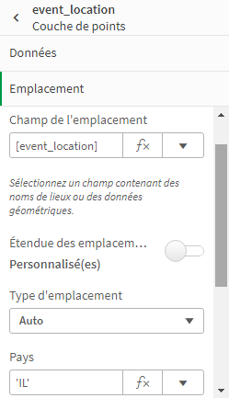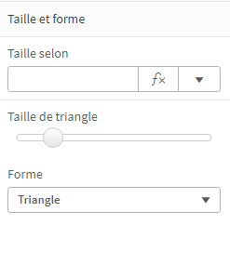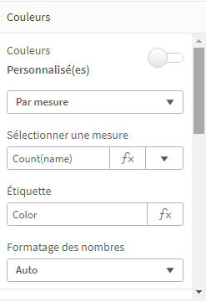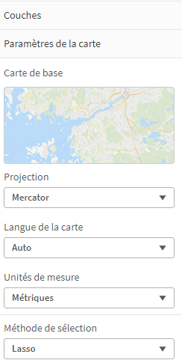

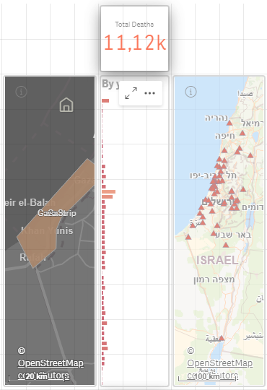

  - Adding a Trend Analysis with a Line Chart :
To visualize The Rate of Deaths by year
• Open the Visualization Pane:
- Navigate to the Visualization Pane in your Qlik Sense workspace.
• Drag and Drop the Line Chart:
- Drag the Line Chart visualization onto your canvas.
• Add Data Fields:
- Dimension (x-axis): Select a time-based field Year(date_of_death) to represent the timeline.
- Measure (y-axis): Choose a numerical field to represent the trend in our case it is :
rangesum(above(count(name), 0, 3)) calculates a rolling total over the current row and the two rows above it in a chart.
- count(name) counts how many names are in each row.
- above(..., 0, 3) looks at the current row and the two rows above it.
- rangesum(...) adds up those counts.
This helps us see a smoother trend in the data, rather than just the individual counts for each row

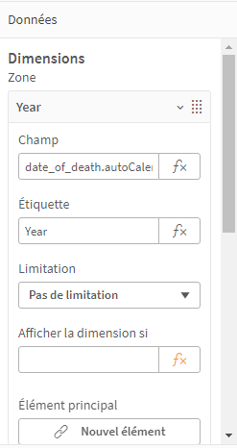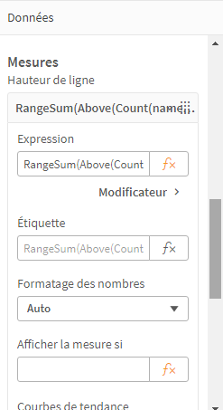

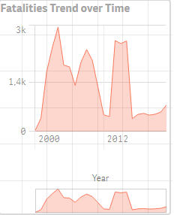

    - Seeing what is the most common injury :
• The KPI object is added from the visualization panel.
• The formula below is entered as the measure for the KPI.
• The KPI displays the most frequent injury type directly, making it easy to identify the most common issue at a glance
Expression :
FirstSortedValue(type_of_injury), -Aggr(Count(type_of_injury),type_of_injury)

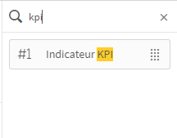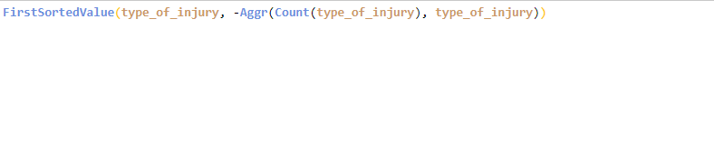
- Count(type_of_injury)
  - This counts the number of occurrences for each type of injury in the dataset.
- Aggr(Count(type_of_injury), type_of_injury)
  - The Aggr() function creates an aggregated result where it calculates the count of each injury type and groups them by type_of_injury.

- -Aggr(...)
  - The minus sign (-) reverses the order of the counts so that the injury with the highest count appears first (descending order).
- FirstSortedValue(type_of_injury, -Aggr(...))
  - This picks the type_of_injury with the highest count .

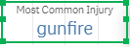

  - Plotting the Deaths by age average through years :

Click on Add Object and select Scatter Plot from the list of chart types.
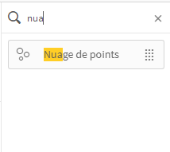
• Add Data Fields:
- (x-axis): Select a time-based field in our case count of names .
- (y-axis): Choose a numerical field to represent the trend in our case it is average of age
- Size : count name
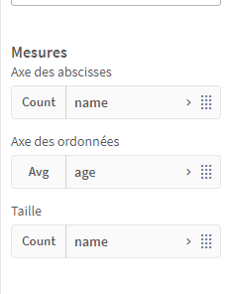

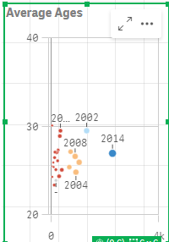

  - Visualizing gender Difference :
• Click on Add Object or drag a Pie Chart from the right panel into the sheet.
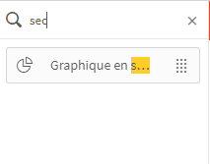
• Configure the Pie Chart:
Dimension (Slices of the Pie):
  - Drag the gender field into the Dimensions section. This will split the pie chart by male and female categories.

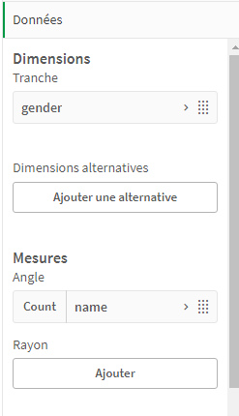
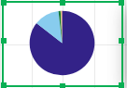
  - Same way to Visualize deaths by killer, injuries and type of ammunition :
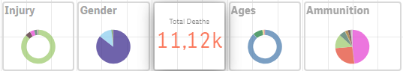
Using Master Items :

  - Getting the number of regions affected as a master Item :
• Add a Measure:
- Count ‘event_location’
- Set it to count unique values if it represents distinct regions.
• Expression:
- Count( distinct event_location)
• Name Item:
- For after Use . We’ll use ‘Regions’

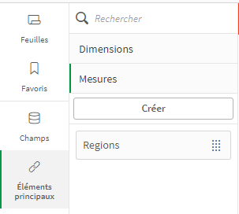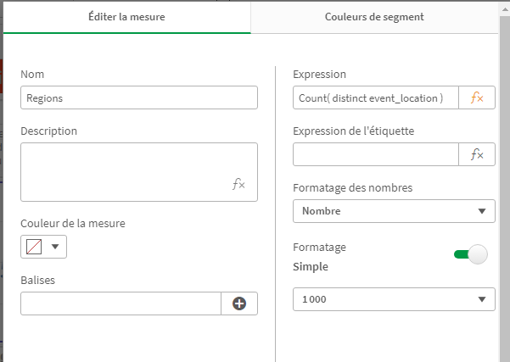

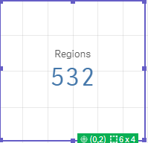

  - Using Master Items to create Visualizations :
• Select the Bar Chart Option:
- Choose the Bar Chart visualization type.
• Add Dimensions and Measures:
- Drag ‘date_of_death.year’ to the Dimensions section.
- Drag ‘Regions’ as a Measure
.

